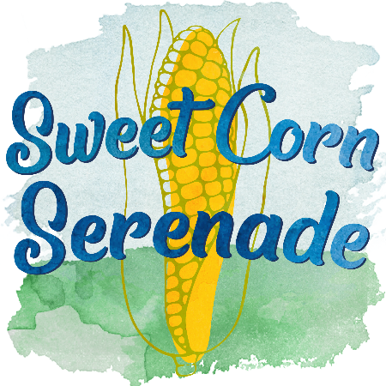
Craft +Vendor Fair
SWEET CORN SERENADE
Thursday, July 25th, 2024
City Square Park in Historic Downtown Oskaloosa

EVENT INFORMATION: Sell your products at the Craft & Vendor Fair held in conjunction with Sweet Corn Serenade! Oskaloosa Main Street’s annual Sweet Corn Serenade brings 3,000 people to downtown Oskaloosa for fresh-cooked sweet corn and live music. This year’s festival will happen July 25th from 12 PM – 9 PM, and will include a craft and vendor fair, food trucks, children’s activities, and more!

LOCATION: Sweet Corn Serenade will take place in Oskaloosa’s City Square Park. To receive your spot assignment, all vendors must check in with volunteers before the event. As in past years, the rain location is Penn Central Mall.

ELIGIBILITY: Vendors are permitted to sell a wide variety of items including décor, crafts, clothing, jewelry, homewares, and more. Vendors must have at least 12 items available for sale. Items must be family-friendly.

REGISTRATION & FEE: Submit the non-refundable fee per space with your complete registration form. Fees (including tax) are based on the registration submission dates below:
$50 Early Bird • Register by June 17, 2024 $60 Final • Register by July 15, 2024
Fee covers one vendor space approximately 12x12 situated in the grass. As a vendor, you are responsible for your own tables, chairs, displays, and canopy/tent, including protection for wind and sun; no sheltered spaces will be provided.

NOTE: Oskaloosa Main Street’s Art on the Square will take place Saturday, June 8th, 2024. If you’re an artist who would like to submit your creative work for consideration in the juried show, please email or call Oskaloosa Main Street Director (contact info below) for more details.

QUESTIONS? Learn more at mahaskachamber.org/events/sweet_corn_serenade. If you have questions, please email or call Oskaloosa Main Street Director (contact info below).

Contact:
Vicki Van Donselaar or Morgan McClendon
chamber@mahaskachamber.org • 641-672-2591

KEEP THIS SECTION FOR YOUR RECORDS:
Number of spaces needed: One ☐ Two ☐ Amount enclosed: Click or tap here to enter text.
Early Bird: $50 per space through June 17, 2024
Final Deadline: $60 per space after June 17 up to July 15, 2024
Make checks payable to Mahaska Chamber Attn: Main Street. All fees are non-refundable. Vendor agrees and understands that the applicant will carry all necessary insurance covering all individual property displayed and any necessary Iowa tax permits. This is the sole responsibility of the vendor.
Detach and return entire lower portion (below dotted line) along with registration fee.
…………………………………………………………………………………………………………………………..
Craft +Vendor Fair Registration
2024 SWEET CORN SERENADE REGISTRATION
$50 Early Bird • Register by June 17, 2024 $60 Final Deadline • Register by July 15, 2024
Name: Click or tap here to enter text.
Address: Click or tap here to enter text. City/State/ZIP: Click or tap here to enter text.
Iowa Sales Tax Number: Click or tap here to enter text.
Phone (work): Click or tap here to enter text. Phone (home/cell): Click or tap here to enter text.
Email: Click or tap here to enter text.
Description of items for sale:
Click or tap here to enter text.

Please check # of spaces required: One ☐ Two ☐
Electricity ($3.00): ☐ Yes ☐ No
Canopy? (Must supply your own): ☐Yes ☐No If yes, canopy size: Click or tap here to enter text.
Special Requests (requests cannot be guaranteed): Click or tap here to enter text.
Along with this registration form, submit the following:
☐ Non-refundable registration fee per space
☐ Photo(s) of products (optional; may be posted on social media for publicity purposes)

Submit to Oskaloosa Main Street at 222 1st Avenue East, Oskaloosa, IA 52577, or email to mahaska@mahaskachamber.org. Space is limited—early registration encouraged! Make checks payable to Mahaska Chamber Attn: Main Street. Final deadline to register is July 15, 2024.

It is hereby agreed and understood that the undersigned will carry all necessary insurance covering all property displayed by him/her and any necessary Iowa tax permits at Sweet Corn Serenade Craft + Vendor Fair on July 25th, 2024.

Signature: Click or tap here to enter text. Date: Click or tap here to enter text.

Office Use Only
Date Submitted: Click or tap here to enter text. Registration Fee: Click or tap here to enter text. Acceptance Form Returned: Click or tap here to enter text.

